UNIANOVA response BY factor1 factor2
/METHOD=SSTYPE(3)
/INTERCEPT=INCLUDE
/SAVE=PRED RESID ZRESID SRESID
/POSTHOC=factor1 factor2(TUKEY DUNCAN LSD DUNNETT)
/CRITERIA=ALPHA(0.05)
/DESIGN=factor1 factor2.

Univariate Analysis of Variance

Notes
Output Created |  | 12-JUN-2021 12:23:20
Comments
Input | Data | F:\lessons\طرح آزمایش ها\codes\first.sav
Input | Active Dataset | DataSet0
Input | Filter | <none>
Input | Weight | <none>
Input | Split File | <none>
Input | N of Rows in Working Data File | 20
Missing Value Handling | Definition of Missing | User-defined missing values are treated as missing.
Missing Value Handling | Cases Used | Statistics are based on all cases with valid data for all variables in the model.
Syntax |  | UNIANOVA response BY factor1 factor2  /METHOD=SSTYPE(3)  /INTERCEPT=INCLUDE  /SAVE=PRED RESID ZRESID SRESID  /POSTHOC=factor1 factor2(TUKEY DUNCAN LSD DUNNETT)  /CRITERIA=ALPHA(0.05)  /DESIGN=factor1 factor2.
Resources | Processor Time | 00:00:00.27
Resources | Elapsed Time | 00:00:00.25
Variables Created or Modified | PRE_1 | Predicted Value for response
Variables Created or Modified | RES_1 | Residual for response
Variables Created or Modified | ZRE_1 | Standardized Residual for response
Variables Created or Modified | SRE_1 | Studentized Residual for response

Between-Subjects Factors
 |  | Value Label | N
factor1 | 1.00 | 1 | 5
factor1 | 2.00 | 2 | 5
factor1 | 3.00 | 3 | 5
factor1 | 4.00 | 4 | 5
factor2 | 1.00 | 1 | 4
factor2 | 2.00 | 2 | 4
factor2 | 3.00 | 3 | 4
factor2 | 4.00 | 4 | 4
factor2 | 5.00 | 5 | 4

Tests of Between-Subjects Effects
Dependent Variable: response
Source | Type III Sum of Squares | df | Mean Square | F | Sig.
Corrected Model | 169.950ª | 7 | 24.279 | 13.364 | .000
Intercept | 102961.250 | 1 | 102961.250 | 56675.917 | .000
factor1 | 12.950 | 3 | 4.317 | 2.376 | .121
factor2 | 157.000 | 4 | 39.250 | 21.606 | .000
Error | 21.800 | 12 | 1.817
Total | 103153.000 | 20
Corrected Total | 191.750 | 19

a. R Squared = .886 (Adjusted R Squared = .820)

Post Hoc Tests

factor1

Multiple Comparisons
Dependent Variable: response
 | (I) factor1 | (J) factor1 | Mean Difference (I-J) | Std. Error | Sig. | 95% Confidence Interval
 |  |  |  |  |  | Lower Bound
Tukey HSD | 1 | 2 | -.8000 | .85245 | .785 | -3.3308
Tukey HSD | 1 | 3 | -1.8000 | .85245 | .204 | -4.3308
Tukey HSD | 1 | 4 | -2.0000 | .85245 | .142 | -4.5308
Tukey HSD | 2 | 1 | .8000 | .85245 | .785 | -1.7308
Tukey HSD | 2 | 3 | -1.0000 | .85245 | .654 | -3.5308
Tukey HSD | 2 | 4 | -1.2000 | .85245 | .518 | -3.7308
Tukey HSD | 3 | 1 | 1.8000 | .85245 | .204 | -.7308
Tukey HSD | 3 | 2 | 1.0000 | .85245 | .654 | -1.5308
Tukey HSD | 3 | 4 | -.2000 | .85245 | .995 | -2.7308
Tukey HSD | 4 | 1 | 2.0000 | .85245 | .142 | -.5308
Tukey HSD | 4 | 2 | 1.2000 | .85245 | .518 | -1.3308
Tukey HSD | 4 | 3 | .2000 | .85245 | .995 | -2.3308
LSD | 1 | 2 | -.8000 | .85245 | .367 | -2.6573
LSD | 1 | 3 | -1.8000 | .85245 | .056 | -3.6573
LSD | 1 | 4 | -2.0000* | .85245 | .037 | -3.8573
LSD | 2 | 1 | .8000 | .85245 | .367 | -1.0573
LSD | 2 | 3 | -1.0000 | .85245 | .264 | -2.8573
LSD | 2 | 4 | -1.2000 | .85245 | .185 | -3.0573
LSD | 3 | 1 | 1.8000 | .85245 | .056 | -.0573
LSD | 3 | 2 | 1.0000 | .85245 | .264 | -.8573
LSD | 3 | 4 | -.2000 | .85245 | .818 | -2.0573
LSD | 4 | 1 | 2.0000* | .85245 | .037 | .1427
LSD | 4 | 2 | 1.2000 | .85245 | .185 | -.6573
LSD | 4 | 3 | .2000 | .85245 | .818 | -1.6573
Dunnett t (2-sided)^{b} | 1 | 4 | -2.0000 | .85245 | .090 | -4.2870
Dunnett t (2-sided)^{b} | 2 | 4 | -1.2000 | .85245 | .392 | -3.4870
Dunnett t (2-sided)^{b} | 3 | 4 | -.2000 | .85245 | .991 | -2.4870

Homogeneous Subsets

response
 | factor1 | N | Subset
 | factor1 | N | 1 | 2
Tukey HSD^{a,b} | 1 | 5 | 70.6000
Tukey HSD^{a,b} | 2 | 5 | 71.4000
Tukey HSD^{a,b} | 3 | 5 | 72.4000
Tukey HSD^{a,b} | 4 | 5 | 72.6000
Tukey HSD^{a,b} | Sig. |  | .142
Duncan^{a,b} | 1 | 5 | 70.6000
Duncan^{a,b} | 2 | 5 | 71.4000 | 71.4000
Duncan^{a,b} | 3 | 5 | 72.4000 | 72.4000
Duncan^{a,b} | 4 | 5 |  | 72.6000
Duncan^{a,b} | Sig. |  | .067 | .205

Means for groups in homogeneous subsets are displayed.
Based on observed means.
The error term is Mean Square(Error) = 1.817.
a. Uses Harmonic Mean Sample Size = 5.000.
b. Alpha = 0.05.

factor2

Multiple Comparisons
Dependent Variable: response
 | (I) factor2 | (J) factor2 | Mean Difference (I-J) | Std. Error | Sig. | 95% Confidence Interval
 |  |  |  |  |  | Lower Bound | Upper Bound
Tukey HSD | 1 | 2 | 5.0000* | .95307 | .002 | 1.9622 | 8.0378
Tukey HSD | 1 | 3 | -2.0000 | .95307 | .281 | -5.0378 | 1.0378
Tukey HSD | 1 | 4 | .7500 | .95307 | .930 | -2.2878 | 3.7878
Tukey HSD | 1 | 5 | 5.0000* | .95307 | .002 | 1.9622 | 8.0378
Tukey HSD | 2 | 1 | -5.0000* | .95307 | .002 | -8.0378 | -1.9622
Tukey HSD | 2 | 3 | -7.0000* | .95307 | .000 | -10.0378 | -3.9622
Tukey HSD | 2 | 4 | -4.2500* | .95307 | .006 | -7.2878 | -1.2122
Tukey HSD | 2 | 5 | .0000 | .95307 | 1.000 | -3.0378 | 3.0378
Tukey HSD | 3 | 1 | 2.0000 | .95307 | .281 | -1.0378 | 5.0378
Tukey HSD | 3 | 2 | 7.0000* | .95307 | .000 | 3.9622 | 10.0378
Tukey HSD | 3 | 4 | 2.7500 | .95307 | .083 | -.2878 | 5.7878
Tukey HSD | 3 | 5 | 7.0000* | .95307 | .000 | 3.9622 | 10.0378
Tukey HSD | 4 | 1 | -.7500 | .95307 | .930 | -3.7878 | 2.2878
Tukey HSD | 4 | 2 | 4.2500* | .95307 | .006 | 1.2122 | 7.2878
Tukey HSD | 4 | 3 | -2.7500 | .95307 | .083 | -5.7878 | .2878
Tukey HSD | 4 | 5 | 4.2500* | .95307 | .006 | 1.2122 | 7.2878
Tukey HSD | 5 | 1 | -5.0000* | .95307 | .002 | -8.0378 | -1.9622
Tukey HSD | 5 | 2 | .0000 | .95307 | 1.000 | -3.0378 | 3.0378
Tukey HSD | 5 | 3 | -7.0000* | .95307 | .000 | -10.0378 | -3.9622
Tukey HSD | 5 | 4 | -4.2500* | .95307 | .006 | -7.2878 | -1.2122
LSD | 1 | 2 | 5.0000* | .95307 | .000 | 2.9234 | 7.0766
LSD | 1 | 3 | -2.0000 | .95307 | .058 | -4.0766 | .0766
LSD | 1 | 4 | .7500 | .95307 | .447 | -1.3266 | 2.8266
LSD | 1 | 5 | 5.0000* | .95307 | .000 | 2.9234 | 7.0766
LSD | 2 | 1 | -5.0000* | .95307 | .000 | -7.0766 | -2.9234
LSD | 2 | 3 | -7.0000* | .95307 | .000 | -9.0766 | -4.9234
LSD | 2 | 4 | -4.2500* | .95307 | .001 | -6.3266 | -2.1734
LSD | 2 | 5 | .0000 | .95307 | 1.000 | -2.0766 | 2.0766
LSD | 3 | 1 | 2.0000 | .95307 | .058 | -.0766 | 4.0766
LSD | 3 | 2 | 7.0000* | .95307 | .000 | 4.9234 | 9.0766
LSD | 3 | 4 | 2.7500* | .95307 | .014 | .6734 | 4.8266
LSD | 3 | 5 | 7.0000* | .95307 | .000 | 4.9234 | 9.0766
LSD | 4 | 1 | -.7500 | .95307 | .447 | -2.8266 | 1.3266
LSD | 4 | 2 | 4.2500* | .95307 | .001 | 2.1734 | 6.3266
LSD | 4 | 3 | -2.7500* | .95307 | .014 | -4.8266 | -.6734
LSD | 4 | 5 | 4.2500* | .95307 | .001 | 2.1734 | 6.3266
LSD | 5 | 1 | -5.0000* | .95307 | .000 | -7.0766 | -2.9234
LSD | 5 | 2 | .0000 | .95307 | 1.000 | -2.0766 | 2.0766
LSD | 5 | 3 | -7.0000* | .95307 | .000 | -9.0766 | -4.9234
LSD | 5 | 4 | -4.2500* | .95307 | .001 | -6.3266 | -2.1734
Dunnett t (2-sided)^{b} | 1 | 5 | 5.0000* | .95307 | .001 | 2.3247 | 7.6753
Dunnett t (2-sided)^{b} | 2 | 5 | .0000 | .95307 | 1.000 | -2.6753 | 2.6753
Dunnett t (2-sided)^{b} | 3 | 5 | 7.0000* | .95307 | .000 | 4.3247 | 9.6753
Dunnett t (2-sided)^{b} | 4 | 5 | 4.2500* | .95307 | .003 | 1.5747 | 6.9253

Based on observed means.
The error term is Mean Square(Error) = 1.817.
*. The mean difference is significant at the 0.05 level.
b. Dunnett t-tests treat one group as a control, and compare all other groups against it.

Homogeneous Subsets

response
 | factor2 | N | Subset
 | factor2 | N | 1 | 2 | 3
Tukey HSD^{a,b} | 2 | 4 | 68.5000
Tukey HSD^{a,b} | 5 | 4 | 68.5000
Tukey HSD^{a,b} | 4 | 4 |  | 72.7500
Tukey HSD^{a,b} | 1 | 4 |  | 73.5000
Tukey HSD^{a,b} | 3 | 4 |  | 75.5000
Tukey HSD^{a,b} | Sig. |  | 1.000 | .083
Duncan^{a,b} | 2 | 4 | 68.5000
Duncan^{a,b} | 5 | 4 | 68.5000
Duncan^{a,b} | 4 | 4 |  | 72.7500
Duncan^{a,b} | 1 | 4 |  | 73.5000 | 73.5000
Duncan^{a,b} | 3 | 4 |  |  | 75.5000
Duncan^{a,b} | Sig. |  | 1.000 | .447 | .058

Means for groups in homogeneous subsets are displayed.
Based on observed means.
The error term is Mean Square(Error) = 1.817.
a. Uses Harmonic Mean Sample Size = 4.000.
b. Alpha = 0.05.

GRAPH
/SCATTERPLOT(BIVAR)=factor2 WITH RES_1
/MISSING=LISTWISE.

Graph

Notes
Output Created |  | 12-JUN-2021 12:24:10
Comments
Input | Data | F:\lessons\طرح آزمایش ها\codes\first.sav
Input | Active Dataset | DataSet0
Input | Filter | <none>
Input | Weight | <none>
Input | Split File | <none>
Input | N of Rows in Working Data File | 20
Syntax |  | GRAPH  /SCATTERPLOT(BIVAR)=factor2 WITH RES_1  /MISSING=LISTWISE.
Resources | Processor Time | 00:00:00.30
Resources | Elapsed Time | 00:00:00.26

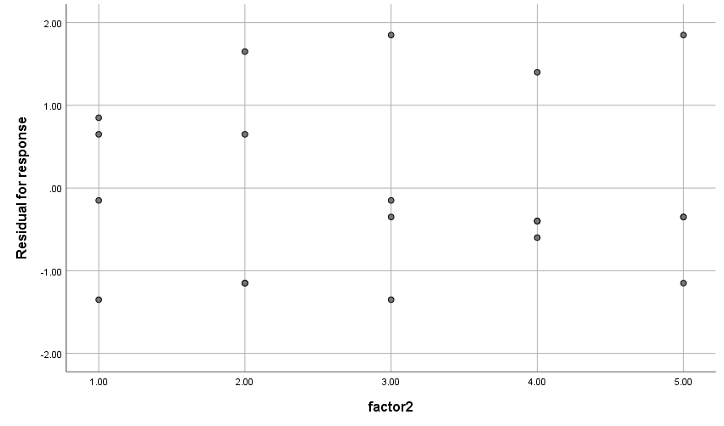

GRAPH
/SCATTERPLOT(BIVAR)=factor2 WITH ZRE_1
/MISSING=LISTWISE.

Graph

Notes
Output Created |  | 12-JUN-2021 12:24:27
Comments
Input | Data | F:\lessons\طرح آزمایش ها\codes\first.sav
Input | Active Dataset | DataSet0
Input | Filter | <none>
Input | Weight | <none>
Input | Split File | <none>
Input | N of Rows in Working Data File | 20
Syntax |  | GRAPH  /SCATTERPLOT(BIVAR)=factor2 WITH ZRE_1  /MISSING=LISTWISE.
Resources | Processor Time | 00:00:00.19
Resources | Elapsed Time | 00:00:00.15

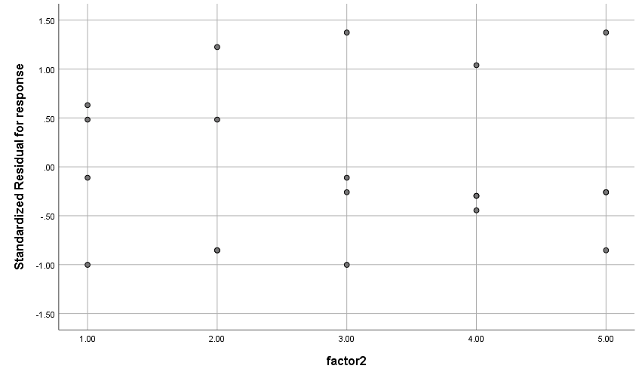

GRAPH
/SCATTERPLOT(BIVAR)=factor2 WITH SRE_1
/MISSING=LISTWISE.

Graph

Notes
Output Created |  | 12-JUN-2021 12:24:46
Comments
Input | Data | F:\lessons\طرح آزمایش ها\codes\first.sav
Input | Active Dataset | DataSet0
Input | Filter | <none>
Input | Weight | <none>
Input | Split File | <none>
Input | N of Rows in Working Data File | 20
Syntax |  | GRAPH  /SCATTERPLOT(BIVAR)=factor2 WITH SRE_1  /MISSING=LISTWISE.
Resources | Processor Time | 00:00:00.19
Resources | Elapsed Time | 00:00:00.16

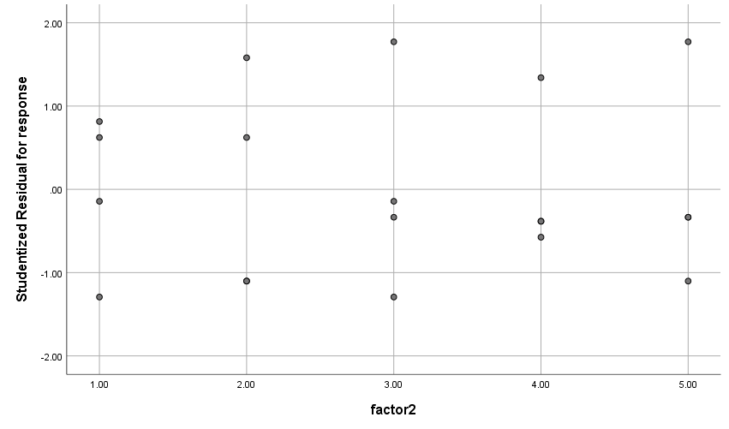

PPLOT
/VARIABLES=RES_1
/NOLOG
/NOSTANDARDIZE
/TYPE=P-P
/FRACTION=BLOM
/TIES=MEAN
/DIST=NORMAL.

PPlot

Notes
Output Created |  | 12-JUN-2021 12:26:44
Comments
Input | Data | F:\lessons\طرح آزمایش ها\codes\first.sav
Input | Active Dataset | DataSet0
Input | Filter | <none>
Input | Weight | <none>
Input | Split File | <none>
Input | N of Rows in Working Data File | 20
Input | Date | <none>
Missing Value Handling | Definition of Missing | User-defined missing values are treated as missing.
Missing Value Handling | Cases Used | For a given sequence or time series variable, cases with missing values are not used in the analysis. Cases with negative or zero values are also not used, if the log transform is requested.
Syntax |  | PPLOT  /VARIABLES=RES_1  /NOLOG  /NOSTANDARDIZE  /TYPE=P-P  /FRACTION=BLOM  /TIES=MEAN  /DIST=NORMAL.
Resources | Processor Time | 00:00:00.34
Resources | Elapsed Time | 00:00:00.28
Use | From | First observation
Use | To | Last observation
Time Series Settings (TSET) | Amount of Output | PRINT = DEFAULT
Time Series Settings (TSET) | Saving New Variables | NEWVAR = CURRENT
Time Series Settings (TSET) | Maximum Number of Lags in Autocorrelation or Partial Autocorrelation Plots | MXAUTO = 16
Time Series Settings (TSET) | Maximum Number of Lags Per Cross-Correlation Plots | MXCROSS = 7
Time Series Settings (TSET) | Maximum Number of New Variables Generated Per Procedure | MXNEWVAR = 60
Time Series Settings (TSET) | Maximum Number of New Cases Per Procedure | MXPREDICT = 1000
Time Series Settings (TSET) | Treatment of User-Missing Values | MISSING = EXCLUDE
Time Series Settings (TSET) | Confidence Interval Percentage Value | CIN = 95
Time Series Settings (TSET) | Tolerance for Entering Variables in Regression Equations | TOLER = .0001
Time Series Settings (TSET) | Maximum Iterative Parameter Change | CNVERGE = .001
Time Series Settings (TSET) | Method of Calculating Std. Errors for Autocorrelations | ACFSE = IND
Time Series Settings (TSET) | Length of Seasonal Period | Unspecified
Time Series Settings (TSET) | Variable Whose Values Label Observations in Plots | Unspecified
Time Series Settings (TSET) | Equations Include | CONSTANT

Model Description
Model Name |  | MOD_2
Series or Sequence | 1 | Residual for response
Transformation |  | None
Non-Seasonal Differencing |  | 0
Seasonal Differencing |  | 0
Length of Seasonal Period |  | No periodicity
Standardization |  | Not applied
Distribution | Type | Normal
Distribution | Location | estimated
Distribution | Scale | estimated
Fractional Rank Estimation Method |  | Blom's
Rank Assigned to Ties |  | Mean rank of tied values

Applying the model specifications from MOD_2

Case Processing Summary
 |  | Residual for response
Series or Sequence Length |  | 20
Number of Missing Values in the Plot | User-Missing | 0
Number of Missing Values in the Plot | System-Missing | 0

The cases are unweighted.

Estimated Distribution Parameters
 |  | Residual for response
Normal Distribution | Location |  | .0000
Normal Distribution | Scale |  | 1.07115

The cases are unweighted.

Residual for response

